Nama : Sulthan Qistani Asyam

Kelas : TE 2E

Absen : 20

**Tugas Flowchart No 3,4,5**

No 4 Flowchart No 5 Flowchart

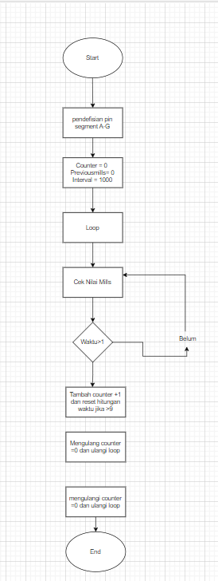 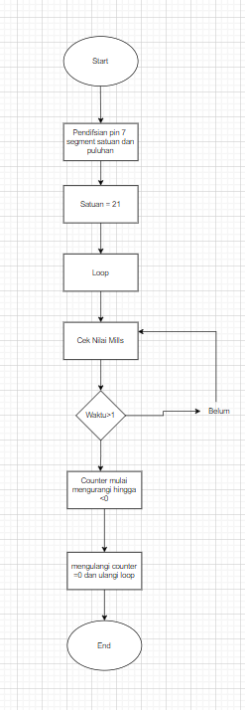

No 3 Flowchart

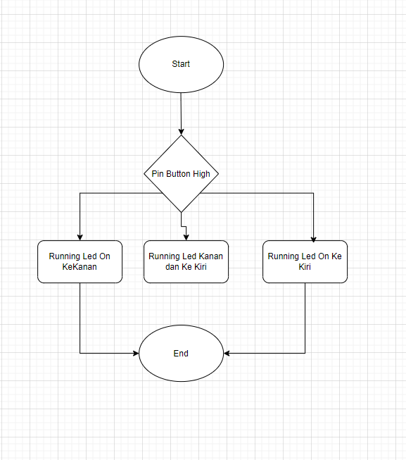

No 6 Flowchart

